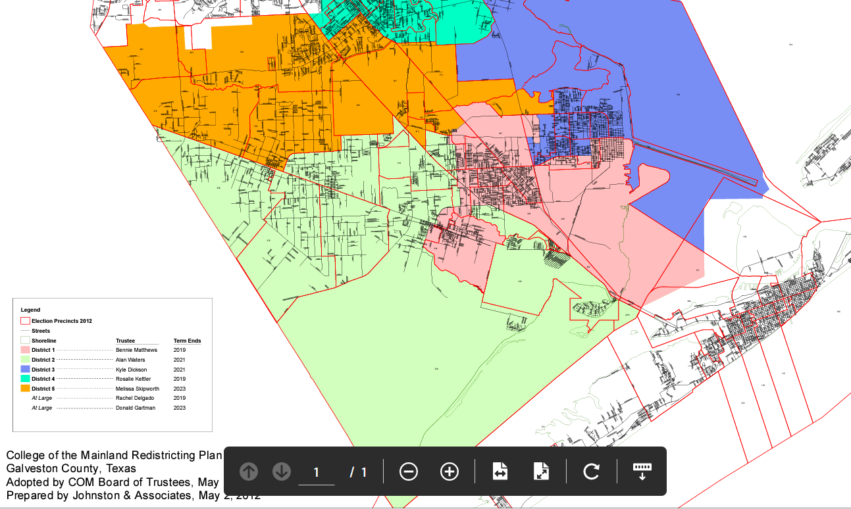

Trustee Term Ends
District 1 Verna Henson 2025
District 2 Alan Waters 2027
District 3 Kyle Dickson 2027
District 4 Dawn King 2025
District 5 Melissa Skipworth 2023
At Large Don Gartman 2023
At Large William McGarvey 2025

Please update the district map page on the website.

https://www.com.edu/bot/

